Instructions to Obtain an eIT PMO Product Account
Instructions for DoD military, civilians, or government contractors.

User Instructions
- User must complete and digitally sign Section A of the eIT PMO Account Request form (see example below).
- Your Knowledge Manager or Supervisor can provide the EDMS permissions and digitally sign Section B of the eIT PMO Account Request Form. (If not, eIT PMO will email the KM to discuss permissions).
- User must provide a current DoD Cyber Awareness Challenge certificate.
  - Training and exam are available here for DoD users
  - Current Cyber Awareness Challenge certificates can be retrieved under Certificates in the JKO Learning Management System

- Email your DoD Cyber Awareness Certificate and signed eIT PMO Account Request Form to the eIT PMO Product Support Mailbox: usarmy.detrick.medcom-usamrmc.mbx.eit-pmo-help-desk@health.mil.

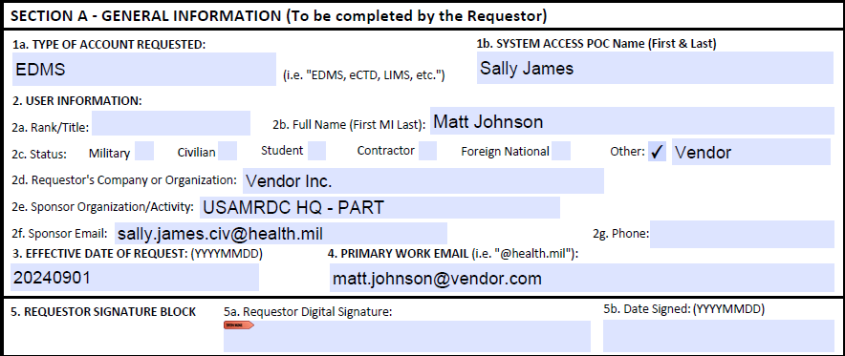
Note: Digital signature is not shown but is required.

