Instructions to Obtain an eIT PMO Product Account
Instructions for non-DoD partners.

- Section A: User requesting access must complete and digitally sign (see example below).
- Section B: If requesting EDMS access, your Knowledge Manager (KM) can provide permissions and digitally sign. (If not, eIT PMO will email the KM to discuss permissions).
- Section C: A DoD government sponsor must complete section C providing approval authority and verifying the requestor meets the following checks:
- Sponsor will check the box verifying the "need-to-know" requirement for the Requestor to access the eIT PMO product.
- Sponsor will check the box that they coordinated with the Unit or Facility Security Officer to ensure a derogatory check (at minimum) has been conducted if the Requestor is a Foreign National.
- Sponsor will digitally sign indicating Approval for creating the Requestor's account.
- User requesting must provide a current DoD Cyber Awareness Challenge certificate.
  - Training and exam are available here for non-DoD users. Choose Cybersecurity Awareness then Launch New Course.
- Email your DoD Cyber Awareness Certificate and signed Account Request Form to the eIT PMO Product Support Mailbox: usarmy.detrick.medcom-usamrmc.mbx.eit-pmo-help-desk@health.mil.
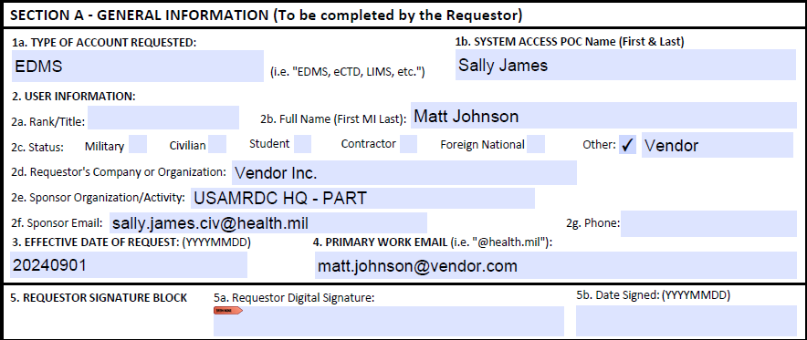
Note: Digital signature is not shown, but is required.

